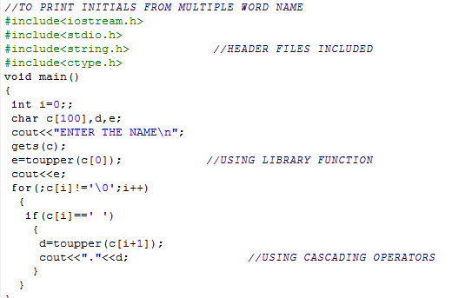

**OUTPUT:**

**F:\c++ 12 th file\madhur\MADHUR\MADHUR\c++  file MADHUR 12\12\name initials\1.PNG**